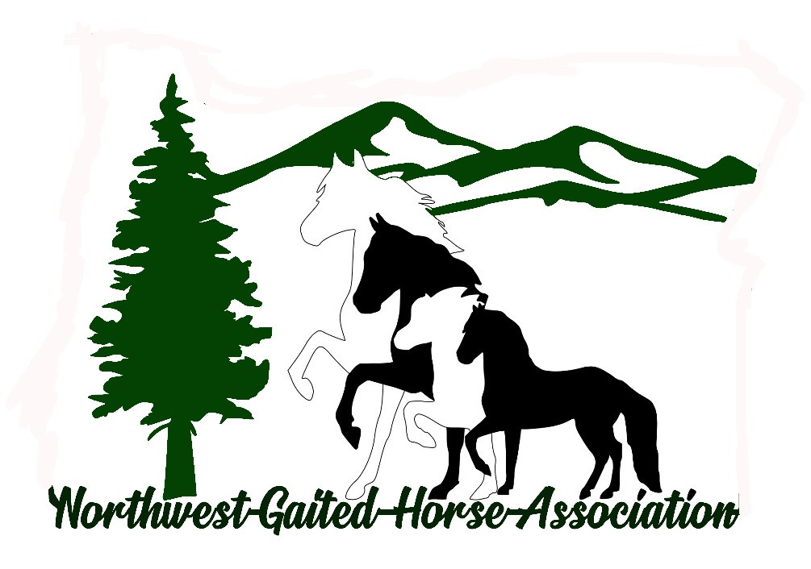
January 19, 2025
9th Annual NGWHA Meeting
With
2024 NWGHA High Points
Awards Presentation

9th Annual Membership Meeting
Agenda
2:00 pm
Year End Comments from Board Members
And Committee Chairs
Minutes from 2024 Annual Membership Meeting
Minutes from 2024 Semi-Annual Membership Meeting
Treasurer Report
NWGHA Show dates and places
2024 Expo in Albany
New USDA/HPA Changes for Horse Shows
Nominations and Election of 2025 Board
Nomination and Election of 2025 Officers
3:30 Awards Presentation

2024 High Point Awards
Confederate’s Black Label – Dan McFarling
Champion: OGB 2 Gait Amateur, TWH 2 Gait Am, TWH 2 Gait Open;
Reserve: OGB 2 Gait Open
Out Til Midnight – Lillian McFarling
Reserve: TWH 2 Gait Open
I’m Totally a Princess – Chris Reznicsek
Champion: OGB 2 Gait Open
Houston We Have a Problem - Carolyn Griffith
Reserve: OGB 2 Gait Amateur
Jose’s Midnight Promise – Kiah Sogaard
Champion: Model Halter
Reserve: TWH 2 Gait Amateur
Nite’s Cash for Jazz - Mary Sjogren
Champion: OGB 3 Gait Open & TWH 3 Gait
I’m 100 Proof Jose - Airisa Durand
Reserve: Model Halter, OGB 3 Gait Open & TWH 3 Gait
Knight’s Ritzy Lady - Tina Dickson
Champion: OGB + TWH 2 Gait & 5 and Under 2 Gait
Jose on Ice - Kristine Mathison
Champion: TWH 2 Gait AOT+ OGB 2 Gait AOT
Prater’s Buckeroo - Tina Dickson
Tie Reserve: TWH 2 Gait + OGB 2 Gait AOT
Walking on Ice - Rachel Ettestad
Tie Reserve: TWH 2 Gait + OGB 2 Gait AOT
Scaramouche - Cindy Kavanagh
Champion: Novice – OGB/TWH 2 Gait
MLM Magico – Anne Eades
Champion: Peruvian Horse
Reserve: Versatility
RSTD Salvador – Larry Eades
Champion: Versatility
Reserve: Peruvian Horse
Snillingur- Lori Birge
Champion: Icelandic
Lolita fro Valkyrie - Jennifer Quinn
Reserve: Icelandic and Novice – OGB/TWH 2 Gait

Barney’s Ali Oops - Caroline Mottram –
Champion: TWH Youth 2 Gait
Aradis from Five Gait Farm – Laura Shaloub
Champion: OGB 2 Gait/Peruvian Youth
Ultima – Christopher Springer
Reserve: OGB 2 Gait/Peruvian Youth

Trail And Promotion Awards
Shannon Clark ~ She’s Armed and Loaded
719.65 Hours
Dalaney Clark ~ High Velocity Jazz
663.90 Hours
Coral Stafford ~ CR Magico
87 Hours
Chris Reznicsek ~ I’m Totally A Princess
47.6 Hours
And Promotion ~ Horse Expo
Glenn Cox ~ RSTD Esteban
25 Hours
Diana Harris ~ Skuggi
24.67 Hours

